LOVINGTON POLICE DEPARTMENT
EMPLOYMENT APPLICATION

Date Received: Received by:

It is the policy of the City of Lovington, New Mexico to provide equality of opportunity in employment, pay, and all other aspects of our personnel policies, practices, and programs. This policy prohibits discrimination on the basis of race, creed, color, ancestry, national origin, political affiliation, sex, sexual preference, age, or physical or mental disability.

PLEASE COMPLETE ALL APPLICABLE ITEMS WITH INK OR TYPEWRITER. ANY ILLEGIBLE SECTIONS, INCOMPLETE SECTIONS & ATTACHEMENTS, OR UNSIGNED APPLICATIONS WILL BE DISMISSED. IF A SECION MUST BE LEFT BLANK, YOU MUST WRITE OR TYPE “N/A” ON THE APPROPRIATE LINE.

POSITION APPLYING FOR:
Date Available:

PERSONAL INFORMATION:

Name:
Last First Middle

Current Address:
Street and Mailing

City State Zip Code

Telephone Number Where You May Be Reached:

/ /
Home Work Cell
DRIVER’S LICENSE NUMBER, CLASS, EXPIRATION AND STATE OF ISSUE:

Have you ever been employed by or are known by any other names- if so, please list below:

EDUCATION, SKILLS & TRAINING:

Please circle the highest year of education completed:

1 2 3 4 5 6 7 8 9 10 11 12 or GED 1 2 3 4 1 2 3 4 5 6 more
Elementary and Secondary College Post Graduate

Schools Attended | Name & Location | Dates Attended | Degree/Certificate | Field of Study
High School

College/University

Vocational/Technical

Are you a certified law enforcement officer? If so, list the State of Certification, certification number and date you received certification:

List any correspondence courses, seminars, workshops, or other training relating to the position applied for:

List any current licenses, registrations, or certificates you have received relating to the position applied for:

What languages can you speak other than English?

List any skills or abilities you have learned that relates to the position applied for:

NEPOTISM: New Mexico law controls the hiring of relatives of officials in certain cases. Please list any relatives by blood or marriage, who are currently employees or elected officials of the City of Lovington, New Mexico.

Name: Relation to You:

PREVIOUS EMPLOYMENT: List paid employment including service with the armed forces. Begin with your current or most recent employment.

1. Employer’s Name: | Your Title(s):
Address: | Job Duties:
Dates Employed:  From: To: | Why did you leave:
Pay: Starting - Final - | Supervisor’s Name:  May we contact your employer? Y N

2. Employer’s Name: | Your Title(s):
Address: | Job Duties:
Dates Employed:  From: To: | Why did you leave:
Pay: Starting - Final - | Supervisor’s Name:  May we contact your employer? Y N

3. Employer’s Name: | Your Title(s):
Address: | Job Duties:
Dates Employed:  From: To: | Why did you leave:
Pay: Starting - Final - | Supervisor’s Name:  May we contact your employer? Y N

4. Employer’s Name: | Your Title(s):
Address: | Job Duties:
Dates Employed:  From: To: | Why did you leave:
Pay: Starting - Final - | Supervisor’s Name:  May we contact your employer? Y N

5. Employer’s Name: | Your Title(s):
Address: | Job Duties:
Dates Employed:  From: To: | Why did you leave:
Pay: Starting - Final - | Supervisor’s Name:  May we contact your employer? Y N

RELEASE OF INFORMATION: THIS PAGE MUST BE NOTARIZED BY A NOTARY PUBLIC. FAILURE TO DO SO WILL RESULT IN THIS APPLICATION’S DISMISSAL.

Having made application with the Lovington Police Department, it is my understanding that a comprehensive investigation of my background may be conducted in connection with this application.

I, do hereby give the officials of the Lovington Police Department the authority to conduct such an investigation and do hereby authorize the release of any and all information requested by the Lovington Police Department pertaining to my work history, any arrest information, and other general qualifications for fitness.

I hereby expressly waive any laws, regulations, and/or other rules which otherwise might prevent other parties from disclosing and releasing such records.

A photo-static copy of the Authorization which contains my signature, shall be considered as effective and valid as the original and may be honored by the other parties.

Applicant Name (Print):

Signature of Applicant: Date:

State of New Mexico )
)
County of Lea )

On this day of , 20 , before me personally appeared known to me to be the person whose name is subscribed to the above instrument and acknowledged the same to be his/her own free act and deed.

Notary
(Seal) My Commission Expires:

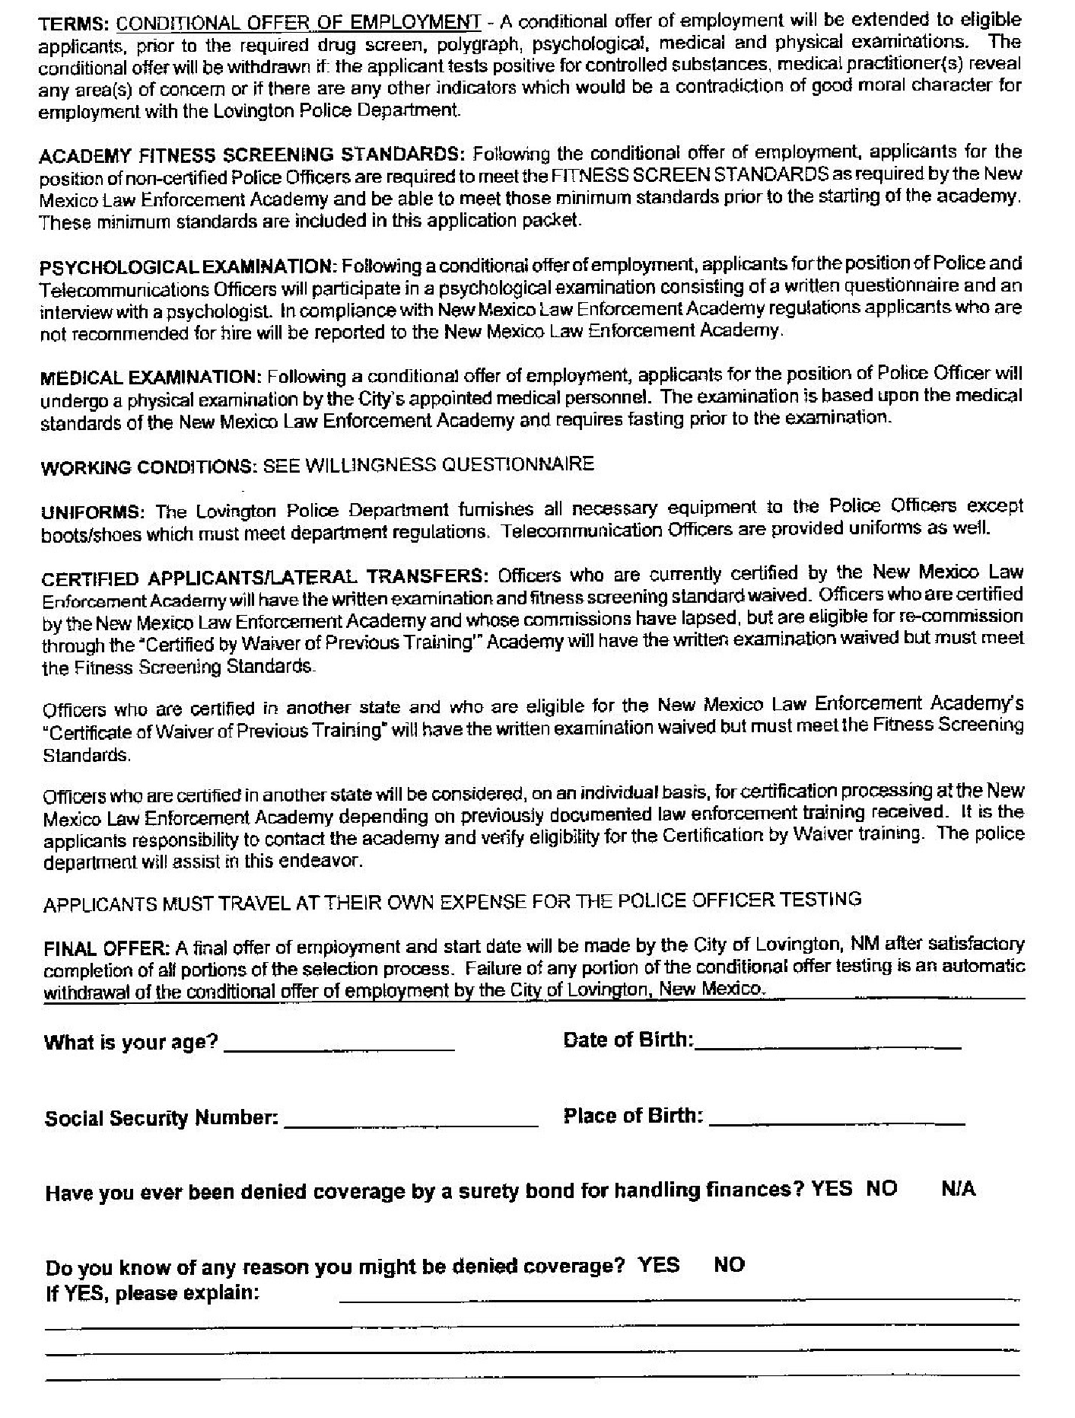

We declare that the existence of a conviction record will not automatically disqualify you from all employment with the City of Lovington, however, certain types of criminal convictions may prohibit you from working in certain jobs.

I, HEREBY AUTHORIZE THE RELEASE TO THE LOVINGTON POLICE DEPARTMENT, OF PAST OR CURRENT INFORMATION CONCERNING CONVICTIONS AGAINST ME FROM ANY AGENCY INCLUDING THE UNITED STATES DEPARTMENT OF DEFENSE OR ANY OF ITS BRANCHES. I DO HEREBY HOLD HARMLESS AND FREE OF LIABILITY ANY SOURCE THAT RELEASES THIS INFORMATION.
(Print first, middle & last name)

Applicant’s Signature Date

APPLICATION, REVIEW EACH SECTION CAREFULLY. FAILURE TO LIST ANY PAST OR PRESENT INFORMATION ON EACH SECTION WILL BE SUBJECT TO YOUR APPLICATION’S DISMISSAL.

Have you ever had your driver’s license suspended or revoked by the licensing authority (state or court) YES NO If “YES”, list the required information in the spaces below:

Dates: |  | State: | Reason:
 | To:
 | To:
 | To:

Have you ever been sentenced to a driver’s improvement school? YES NO If “YES”, list the required information in the spaces below:

Dates: |  | State: | Reason:
 | To:
 | To:
 | To:

List all driving citations/summons you have received as an adult and juvenile, beginning with the most recent:

Month/Year | Charge | City/State | Disposition

ADDRESS HISTORY: In the spaces provide below, list all addresses where you have lived during the past ten (10) years, including military addresses if applicable. BEGIN WITH YOUR CURRENT ADDRESS:

From | To | Street Address | City, State

ALIAS/NICKNAME/OTHER IDENTIFICATIONS: In the spaces provided below, list any other alias, nicknames, or identifications that you have used or other individuals do or have known you by:

Alias/Nickname/Other Identification

CRIMINAL HISTORY: Have you ever been convicted by a court, board, or special judicial authority for any violation of Federal, State, County, or Municipal Law: including events while you were a juvenile and/or events while you were in the military that resulted in loss of pay or privileges, detention, and/or reduction in grade (this does not include traffic offenses unless you were placed into custody)?

YES NO If “YES”, provide the required information in the spaces below:

Date: | Charge: | Location: (City/State) | Disposition

DRIVING HISTORY: Do you currently have a valid driver’s license? YES NO

State: | License Class: | Expiration: | DL Number | Restriction

Have you ever had any other driver’s licences? YES NO If you check “YES”, in the spaces below list all states where you have been licensed and/or all names you have been licensed under:

DL Number | Name | State

If you have served or are serving in the United States Military, list the dates of service, branch, and supervisor contact information:

Branch: | Dates of Service | Supervisor’s Name/Contact #

REFERENCES: List three (3) references that we may contact do not include previous employers/supervisors.

Name | Phone Number | Mailing Address | Relationship – How long known
WILLINGNESS QUESTIONAIRE:

Applicant’s Name:

Please complete the following questions concerning the Police Officer position for which you are applying for and write your answers in the form of “YES” or “NO”.

- Are you willing to stand in the middle of a busy intersection direction traffic wearing a helmet in 110 degree weather?
- Are you willing to physically examine a dead body for signs of injury?
- Are you willing to work on legal holidays (i.e. Christmas Day, Thanksgiving, July 4th)?
- Are you willing to work rotating shifts with days off?
- Are you willing to report for duty upon short notice or on days off-sacrificing personal plans?
- Are you willing to investigate accidents in the rain or snow?
- Are you willing to arrest a friend if necessary?
- Are you willing to spend hours writing reports while on overtime?
- Are you willing to work 16 hours in a row if necessary?
- Are you willing to handle situations that involve the possibility of injury to yourself?
- Are you willing to accept a court decision that runs contrary to your own wishes?
- Are you willing to subject yourself to intense public scrutiny and criticism?
- Are you willing to accept being told exactly what to do?
- Are you willing to maintain your composure while being insulted or sworn at?
- Are you willing to observe an autopsy, if required?
- Are you willing to notify a citizen that a member of their immediate family has just been killed?
- Are you willing to investigate situations involving abused or molested children?
- Are you willing to undergo six (6) months of intensive training before being able to work on your own?
- Are you willing to take another human’s life if necessary and appropriate?
- Are you willing to deal with suicide victims and their families?
- Are you willing to search a dark building for a dangerous suspect if necessary?
- Are you willing to enforce laws that you do not agree with?

IF YOU ANSWERED “NO” ON ANY OF THE QUESTIONS ON THIS WILLINGNESS QUESTIONNAIRE, PLEASE REFRAIN FROM SUBMITTING YOUR APPLICATION.

SIGNATURE OF APPLICANT DATE

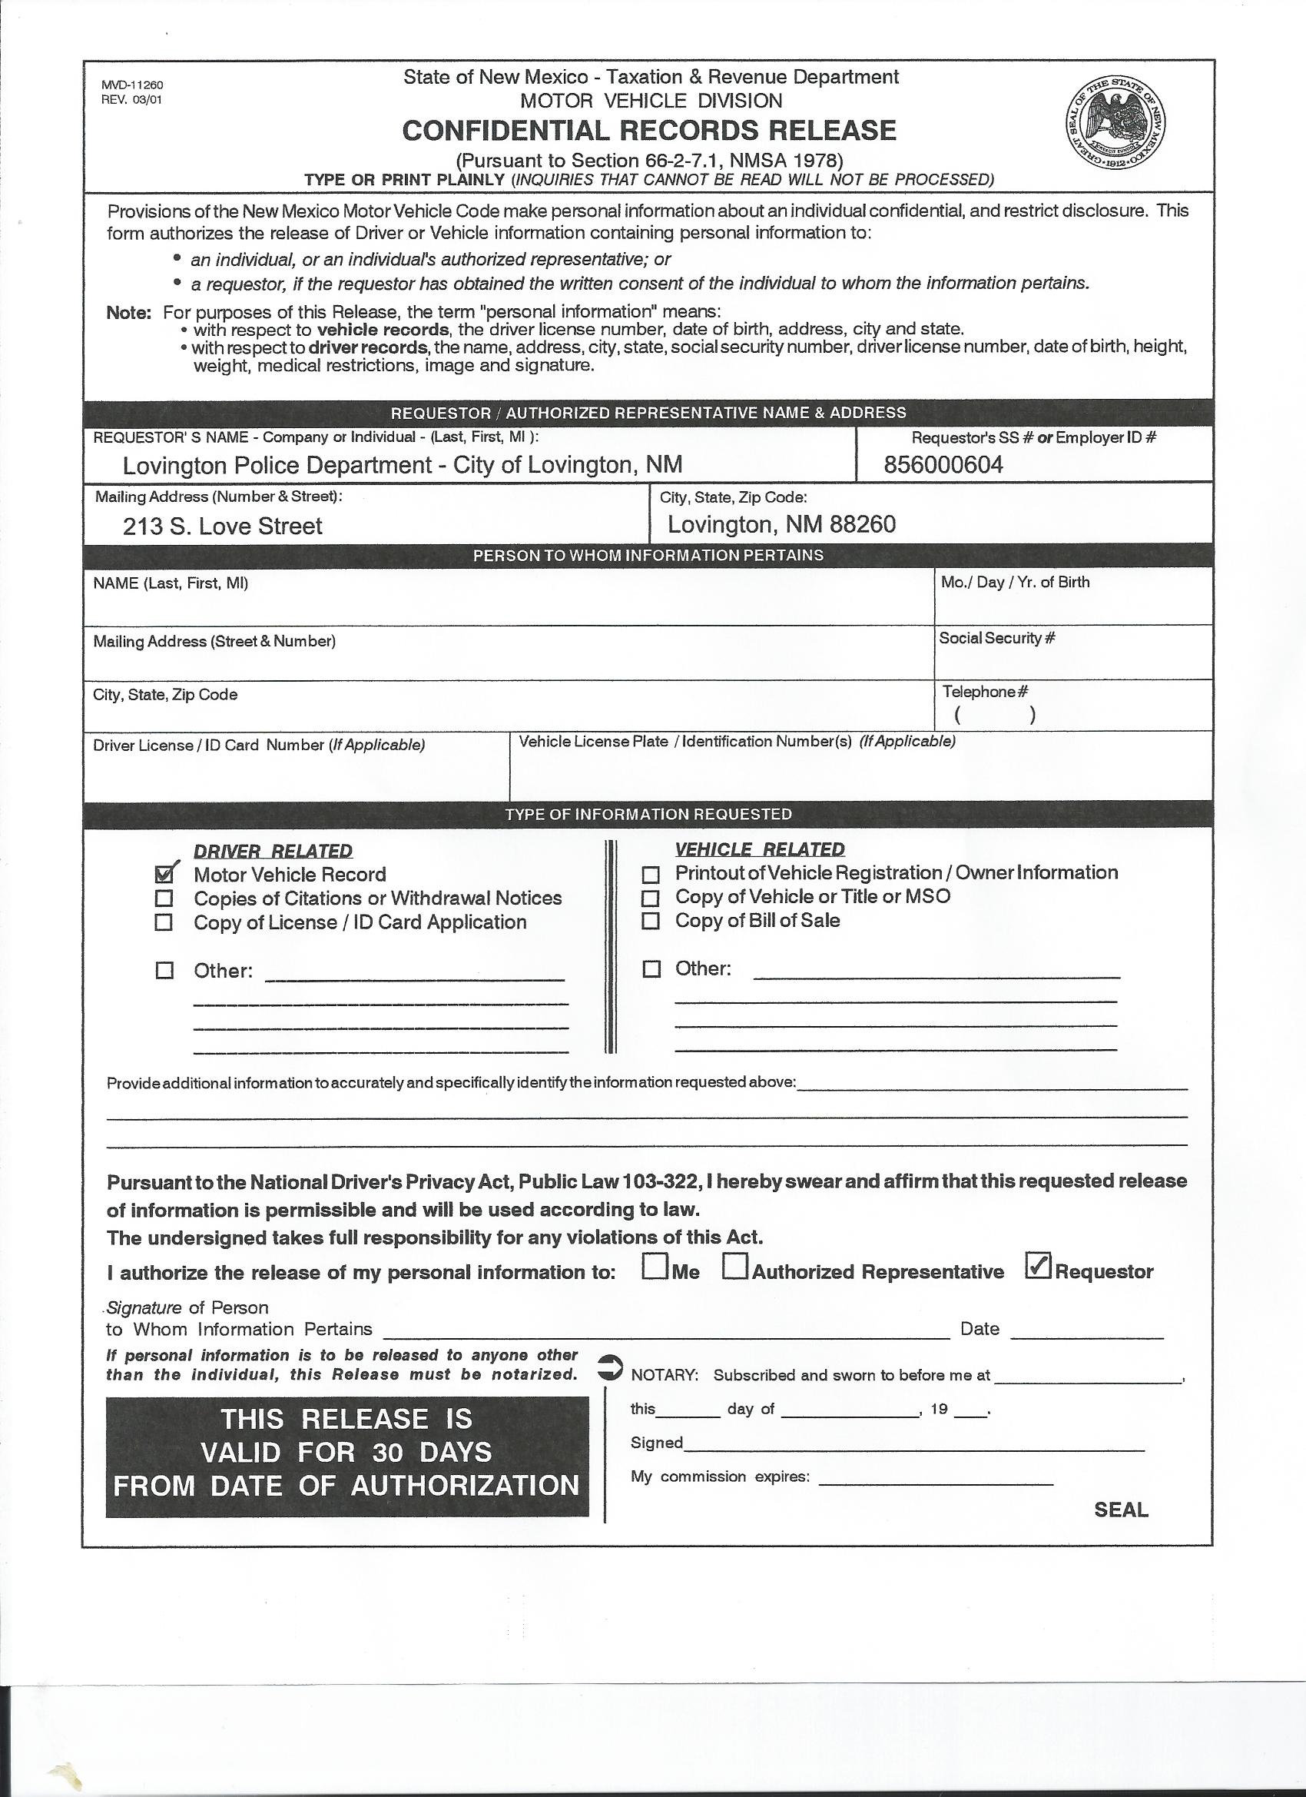
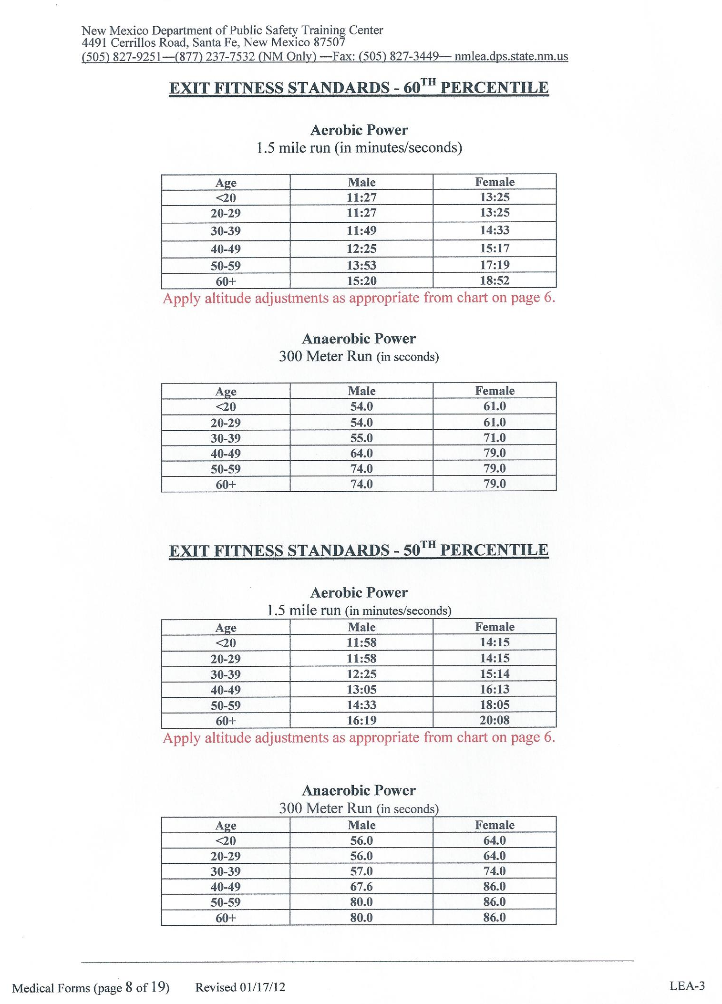
New Mexico Department of Public Safety Training Center
4491 Cerrillos Road, Santa Fe, New Mexico 87507
(505) 827-9251―(877) 237-7532 (NM Only) ―Fax: (505) 827-3449― nmlea.dps.state.nm.us

PHYSICAL PERFORMANCE INFORMATION

The applicant being examined must obtain a medical clearance to participate in the Basic Police Officer Training (BPOT) or Certification by Waiver of Previous Training (CBW) program at the Academy or at an accredited regional/satellite academy. Both programs require a certain level of physical activity as follows:

(1) Fitness Standards, screening for BPOT and certification for BPOT and CBW
(2) Agility Courses
(3) Academy Related Stressors:
(a) Physical Conditioning Program
(b) Defensive Tactics Training
(c) Firearms Training
(d) Academic Requirements

1. Fitness Standards
Prior to entering a BPOT the applicant is screened for a minimum fitness level as measured by a battery of five tests with two potential alternates. These tests are based upon the 40th percentile as established by the Institute for Aerobics Research. Applicants must meet the minimum standard or they will be dismissed from the BPOT program. BPOT applicants are required to complete the 1.5 mile run and 300 meter run at the 60th percentile and the two agility courses prior to certification. CBW applicants are required to complete the 1.5 mile run and 300 meter run at the 50th percentile and the two agility courses prior to certification. See pages 6 and 8.

2. Agility Courses
The applicant must perform simulated job tasks while wearing a ten (10) lb. weight, which represents standard duty equipment. Agility Course 1 - Pursuit: must be completed in 3 minutes and 5 seconds. Agility Course 2 - Rescue: must be completed in 42 seconds. See page 7.

3. Academy-Related Physical Stressors:

3a. Physical Conditioning Program
The BPOT fitness program involves a minimum of 1 hour per day, 3 days a week. The program focuses on cardio-respiratory endurance (aerobics), strength, muscular endurance, speed, agility and balance. Exercise routines may consist of sprinting, long-distance runs of 3 to 5 miles, circuit training calisthenics, a circuit containing agility exercises, a circuit containing power exercises, lifting free weights, floor aerobics and step aerobics. Exercise sessions are both high intensity and high impact.

3b. Defensive Tactics Training
This training will include mat impacts from takedown techniques, aerobic body activity, joint stretching and full range of motion movement. Leg stress may result from kneeling, twisting, turning, standing up and standing for long periods of time. Body stress may result from trunk twisting, bending, hand and grip strength, finger/hand dexterity and eye/hand coordination exercises.

3c. Firearms Training
Applicant needs the ability to maintain continuous good balance, stand for long periods of time, hold a three pound object in an extended arm position long periods, moderate to strong gripping ability, good finger and hand dexterity. Applicant will also need average or above average eye and hand coordination, kneeling ability, and possess uncorrected or corrected visual acuity of 20/30 in both eyes combined.

3d. Academic Requirements
Applicant will sit for long periods of time and maintain a forward leaning position at a table or desk and must possess normal hearing ability, normal writing dexterity and writing ability.

New Mexico Department of Public Safety Training Center
4491 Cerrillos Road, Santa Fe, New Mexico 87507
(505) 827-9251―(877) 237-7532 (NM Only) ―Fax: (505) 827-3449― nmlea.dps.state.nm.us

Medical Forms (page 6 of 19) Revised 01/17/12 LEA-3
ENTRY FITNESS STANDARDS - 40th PERCENTILE

#1 Upper Body Strength
1 minute maximum number of push-ups
Age | Male | Female  Modified | Female  Full Body
20-29 | 29 | 23 | 15
30-39 | 24 | 19 | 11
40-49 | 18 | 13 | 9
50-59 | 13 | 12 | 9
60+ | 10 | 5 | 9

#2 Muscular Endurance #5 Flexibility
1 minute maximum number of sit-ups sit and reach -inches
Age | Male | Female
< 20 | 41 | 32
20-29 | 38 | 32
30-39 | 35 | 25
40-49 | 29 | 20
50-59 | 24 | 14
60+ | 19 | 6

#3 Aerobic Power
1 ½ mile run
Age | Male | Female
< 20 | 12:29 | 15:05
20-29 | 12:29 | 15:05
30-39 | 12:53 | 15:56
40-49 | 13:50 | 17:11
50-59 | 15:14 | 19:10
60+ | 17:19 | 20:55

#4 Anaerobic Power
300 meter run
Age | Male | Female
< 20 | 59.0 | 71.0
20-29 | 59.0 | 71.0
30-39 | 58.9 | 79.0
40-49 | 72.0 | 94.0
50-59 | 83.2 | 94.0
60+ | 83.2 | 94.0

#5 Flexibility
Sit and reach inches
Age | Male | Female
< 20 | 16.5 | 20.5
20-29 | 16.5 | 19.3
30-39 | 15.5 | 18.3
40-49 | 14.3 | 17.3
50-59 | 13.3 | 16.8
60+ | 12.5 | 15.5

Altitude Adjustments for 1 ½ Mile Run
Under 5000 ft. No adjustment
5000 – 5999 ft. add 30 seconds
6000-6999 ft add 40 seconds
7000-8000 ft add 50 seconds
Above 8000 ft. add 60 seconds

